'Romeo and Juliet' teens banned from seeing each other and must wear GPS monitors after running away because parents disproved of their relationship
- Jayden Thomas, 13, and Braxton Wood, 14, found living in SUV near the lake front of Chicago on Sunday morning
- They were last seen on Monday, August 26
- Only had $80 between them plus a few items that could be sold
- A judge rules on Monday they must wear electronic monitors and cannot have contact
- Parents had told both kids their six-month relationship was 'too serious'
Original Article By Rachel Quigley and Helen Pow ; Adapted for Academic Use By Elizabeth Navarro
PUBLISHED: 13:12 EST, 11 September 2013 | UPDATED: 17:04 EST, 11 September 2013
Teen lovers dubbed 'Romeo and Juliet' have been banned from seeing each other and must wear electronic monitors on their ankles after they ran away from home.
A Michigan judge ruled Jayden Thomas, 13, and Braxton Wood, 14, are allowed to return to school but must wear the GPS devices in an effort to stop the pair vanishing again.
The star-crossed lovers from Clare ran away on August 26 after their parents expressed concern about their six-month romance. They were found safe on Sunday - two weeks later - near Chicago.
Neither of the teens spoke during a court hearing on Monday but their families appealed for privacy after the appearance.
'We appreciate the media's response in this case; we appreciate their part in helping us get the kids home,' said Sarah Wood, a relative of Braxton's. 'It's a really hard time for us right now. We do want to thank everybody, but we would appreciate the privacy.'
Chuck Foreman, whose non-profit missing children search organization had been helping in the hunt for the teens, told The Huffington Post that the couple was found by a Good Samaritan who spotted their broken-down Ford Explorer.
'In the area they were found in, for being young kids, it was a very dangerous area. They are very fortunate,' Foreman said.
It's not clear if the teens will face any criminal charges. They are scheduled to appear in court again next month.
Monitored: Jayden Thomas, 13, right, and Braxton Wood, 14, left have to wear GPS anklets to keep them in check

The missing Michigan teenagers were discovered safe in Chicago on Sunday with Braxton's mother's 2005 SUV.
The two young lovers were spotted at a gas station near to Wrigley Firled and an anonymous caller informed the Chicago police who arrived to find the teens in the back of the vehicle in a parking lot adjacent to the station. Sgt. Tim Edeling of the Chicago police department told ABC News that the SUV battery was dead and the pair had run out of gas.
Private investigator, Michael Cook, said that the young teenagers had been living in the car for nearly two weeks after they fled with only $80 between them.
Sgt. Edeling said the teens told him they had been 'going to the local Starbucks and enjoying our lakefront'.
However, Chicago police are trying to gather more information on how the two managed to financially support themselves since they left Clare.
They also want to know what they were doing in Chicago. Inside the SUV, police discovered suitcases belonging to the two, indicating that Wood and Thomas had indeed planned their escape.
The Isabella County Sheriff's Department said Jayden and Braxton were last seen on Monday, August 26, in Clare, Michigan. Braxton took his mother's Ford Explorer.
Then for two weeks, neither family heard anything from them. Both sets of parents said the young couple's relationship had grown too serious too soon.
Vehicle: The teens stole Braxton's mom's 2005 black Ford Explorer, pictured

They were said to have been very upset at the news they would be going to different Michigan high schools, which they would have started this week.
Jayden's mother also revealed that she told her daughter she no longer supported the six-month relationship.
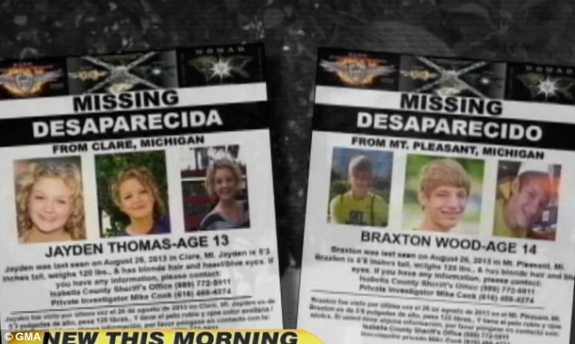
'She wrote a message for me in lipstick on the mirror saying, "I love you so much, stay happy and beautiful."
Jayden’s mother said their six-month relationship was too serious, and Jayden said she could not live without Braxton. The teens had also become obsessed with the story of Romeo and Juliet after reading it in school. The parents became concerned that their kids would do something drastic, knowing that the play Romeo and Juliet has messages of teen sex, drug use, running away, and suicide.
'That's when I felt I had to bring my daughter back to reality. The day she left I told her I no longer supported their relationship. Sure enough, they followed the Romeo and Juliet story and tried to make a decision that was too mature for them. Luckily, we found them before it got even worse.’
The missing posters circulated around the area for the teens who were missing for two weeks

Braxton's mother, Sarah Kiley, said: 'They can't live on their own. They are 13 and 14 years old. They didn't want to do anything but be with each other. It was pretty intense for a 14-year-old.’
Kiley added to ABC: 'We looked around the house and realized Braxton was missing and we still didn't comprehend it because Braxton hasn't had driver's training. He is a young 14, so no drivers' experience whatsoever.'
She said she became concerned when the two of them started alienating friends so they could spend all their time together.
'They didn't want to hang out with friends. Their focus was each other and that's pretty intense for 14-year-olds,' Kiley said, adding that her son did not take the news they were going to different high schools very well.
'Braxton told us he was heartbroken. We thought that they had cooled and were not seeing each other anymore,' she said.
Their parents believe they only had approximately $80, a video game console, a coin collection and other items that could be sold for cash.
West Michigan private eye Mike Cook was part of the team trying to find the teenagers.
'Trying to find these two has been a little bit more difficult than any of us would have thought,' he said before they were finally discovered. 'They are 13 and 14-years-old, boyfriend and girlfriend. It's our impression they have not made contact with anyone.
He warned that the teens may start 'doing things you don't want to see kids do to make money.'

