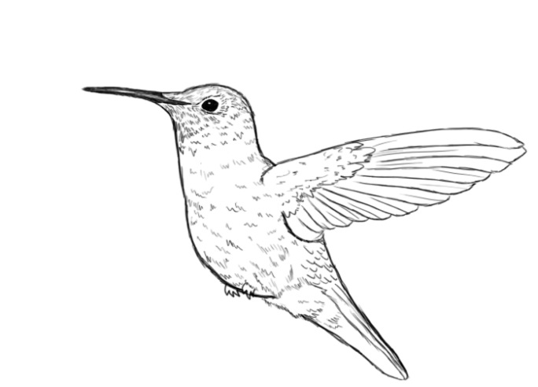
Name____________________________________ Period___________________ Date________________

Song of the Hummingbird Midterm Timed Write
Honors English 10

On a separate sheet of paper, respond to the following
prompt in essay format. Plan an essay that includes an
introduction with a clear thesis statement, body
paragraphs with evidence and analysis, and a thoughtful
conclusion.

You will have one hour to plan and write your essay.

“A” essays will include:
- Introduction, body, conclusion
- A clear thesis statement
- Thoughtful, eloquent, non-repetitive analysis
- Well-chosen and well-placed evidence that flows with the rest of your body paragraphs
- Fluid transitions within and between paragraphs
- A direct response to the prompt
- References to specific characters and events in the plot
- Control of grammar and mechanics
- Academic vocabulary and use of literary terminology
- References to the beginning, middle, and end of the novel

“A” essays will not include:
- Analysis that is simply a summary or paraphrase
- Grammatical and mechanical errors
- “Quote bombs” randomly dropped into your paragraph with no context or fluency
- “This means,” “This matters,” “This is important because,” “What I think they’re trying to say is,” “In my opinion…”

Identify a universal truth (theme) from Song of the Hummingbird. Analyze the development of this theme throughout the novel using evidence from the text and Level 2 and Level 3 analysis.

Examples of universal truths. (You can use one of these if you so choose.)

“History is told by the victor.”
“First impressions are not always correct.”
“Women are as strong as men.”
“Even people who are very different can learn from one another.”
“One should not allow bias to cloud his or her judgment.”
“ People should question history/religion/and authority and formulate their own opinions.”

***Helpful hint: Your thesis statement should state your universal truth. Example thesis statement: “In her novel Song of the Hummingbird, Limon conveys the universal truth that women are as strong as men.”

Sample Essay Outline

Introduction Paragraph:
- Hook (Quote, question, provoking thought)
- Bridge (Transition to the thesis by providing context and background information)
- Thesis Statement

Body: (2-3 paragraphs)
- Write paragraphs in Double TIEAAC style using evidence and thoughtful analysis that support your thesis statement

Conclusion Paragraph:
- Leave the reader with closure by summing up what you have said, restating your thesis statement in a new way, and ending with a poignant final thought

