Name____________________________________ Period___________________ Date________________

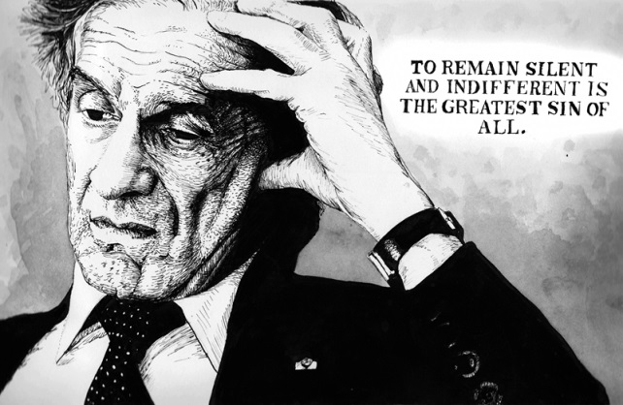
Night Final Timed Write
Honors English 10

On a separate sheet of paper, respond to the following
prompt in essay format. Plan an essay that includes an
introduction with a clear thesis statement, body
paragraphs with evidence and analysis, and a thoughtful
conclusion.

You will have 15 minutes to plan and 45 minutes to write
your essay.

“A” essays will include:
- Introduction, body, conclusion
- A clear thesis statement
- Thoughtful, eloquent, non-repetitive analysis
- Well-chosen and well-placed evidence that flows with the rest of your body paragraphs
- Fluid transitions within and between paragraphs
- A direct response to the prompt
- References to specific characters and events in the plot
- Control of grammar and mechanics
- Academic vocabulary and use of literary terminology
- References to the beginning, middle, and end of the novel

“A” essays will not include:
- Analysis that is simply a summary or paraphrase
- Grammatical and mechanical errors
- “Quote bombs” randomly dropped into your paragraph with no context or fluency
- “This means,” “This matters,” “This is important because,” “What I think they’re trying to say is,” “In my opinion…”
- Second person pronouns

Choose one motif from Night and analyze its significance and/or development over the course of the novel.

Examples of thesis statements. (You can use one of these if you so choose.)

In his memoir, Night, Elie Wiesel develops the motif of _________________ to convey…
In his memoir, Night, Elie Wiesel the motif of _________________ is a symbol that represents…
In his memoir Night, _____________________________ becomes Elie Wiesel’s most significant motif.
In Night, ________________________ is significant because…

- Father and Son Relationships
- Night/Dark/Sleeping/Dreams
- Humans Acting Like/Being Treated Like Animals
- God/Faith/Religion/Loss of Faith
- Silence
- Fire/Smoke/Ashes
Sample Essay Outline

Introduction Paragraph:
- Hook (Quote, question, thought-provoking statement)
- Bridge (Transition to the thesis by providing context and background information)
- Thesis Statement

Body: (2-3 paragraphs)
- Write paragraphs in Double TIEAAC style using evidence and thoughtful analysis that support your thesis statement

Conclusion Paragraph:
- Leave the reader with closure by summing up what you have said, restating your thesis statement in a new way, and ending with a poignant final thought

Purpose for writing (Circle One): Analysis/ Persuasive/ Expository/ Informative/ Narrative

Thesis Statement:

_______________________________________________________________________________________________________________________________________________________________________________________________________________________________________________________________________________________________________________________________________________________________________________________

Evidence Planning:
____________________________________________________________________________________________________________________________________________________________________________________________________________________________________________________________________________________________________________________________________________________________________(Wiesel, _______).

____________________________________________________________________________________________________________________________________________________________________________________________________________________________________________________________________________________________________________________________________________________________________(Wiesel, _______).

____________________________________________________________________________________________________________________________________________________________________________________________________________________________________________________________________________________________________________________________________________________________________(Wiesel, _______).

____________________________________________________________________________________________________________________________________________________________________________________________________________________________________________________________________________________________________________________________________________________________________(Wiesel, _______).

____________________________________________________________________________________________________________________________________________________________________________________________________________________________________________________________________________________________________________________________________________________________________(Wiesel, _______).

____________________________________________________________________________________________________________________________________________________________________________________________________________________________________________________________________________________________________________________________________________________________________(Wiesel, _______).

____________________________________________________________________________________________________________________________________________________________________________________________________________________________________________________________________________________________________________________________________________________________________(Wiesel, _______).

