Name__________________________ Date________________ Period_________
Jim Crow Laws were state and local laws that lasted from the time slavery ended in the late1800s all the way through the Civil Rights Movement (think Martin Luther King, Jr.) in the 1960s. They were meant to keep African Americans “separate but equal” from white people. These laws were mostly in the south, and included strange rules like “No marriage between black and white people” and “Black and white children have to go to different schools” and even “Black and white people cannot drink out of the same drinking fountain.”

What are Jim Crow Laws?

Historical Context for To Kill a Mockingbird: The Jim Crow South
After slavery ended, many of the African Americans who had formerly been slaves working on plantations in the South became “sharecroppers,” which meant that even though they did not own farm land, they worked on farms and were paid by the white farm-owners.
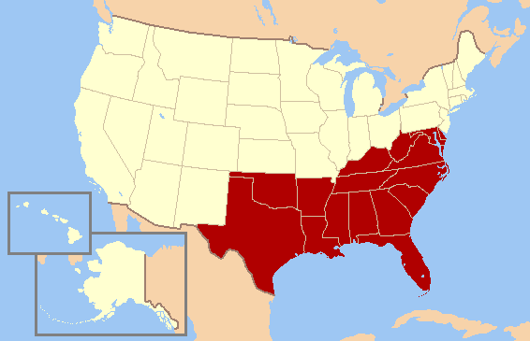
During the Jim Crow era, state and local officers instituted curfews for blacks and posted "Whites Only" and "Colored" signs on parks, schools, hotels, water fountains, restrooms, and all modes of transportation. Laws against miscegenation or "race-mixing" deemed all marriages between white and black people not only void but illegal. Almost as bad as the injustice of Jim Crow was the inconsistency with which law enforcement applied it. Backtalk would rate a laugh in one town, and a lynching just over the county line.
Lynching: is a murder carried out by a mob, often by hanging, but also by burning at the stake or shooting.
Though violence used to subjugate blacks was nothing new, its character changed under Jim Crow. Southern white supremacist groups like the Klu Klux Klan reached a membership of six million. Mob violence was encouraged. Torture became a public spectacle. White families brought their children as witnesses to lynching, and vendors hawked the body parts of victims as souvenirs. Between 1889 and 1930, over 3,700 men and women were reported lynched in the United States, many for challenging Jim Crow.
All this anger and fear led to the notorious trials of the "Scottsboro Boys," an ordeal of sensational convictions, reversals, and retrials for nine young African American men accused of raping two white women on a train from Tennessee to Alabama. The primary testimony came from the older woman, a prostitute trying to avoid prosecution herself. Juries composed exclusively of white men ignored clear evidence that the women had suffered no injury. Just as in To Kill a Mockingbird, a black man charged with raping a white woman was not given the usual presumption of “innocent until proven guilty.” In January of 1932, the Alabama Supreme Court affirmed seven out of eight death sentences against the adult defendants. A central figure in the case was an Atticus-like judge, James E. Horton, a member of the Alabama Bar who eventually defied public sentiment to overturn a guilty verdict.
Atticus is the father and lawyer in our novel, To Kill a Mockingbird who is a white man living at this time period who believes racism and Jim Crow laws to be very unfair. He is one of few white people to actually stand up for equality.

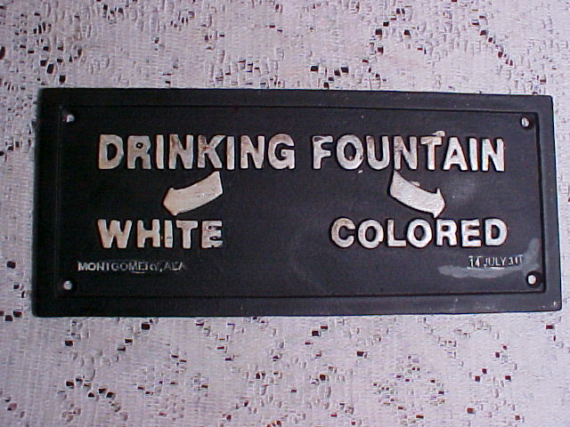
Despite these and many more injustices, black Americans found ingenious ways to endure and resist. Education, religion, and music became their solace and salvation until, in the organized political action of the Civil Rights Movement of the 1960s, Jim Crow's harsh music finally began to fade.
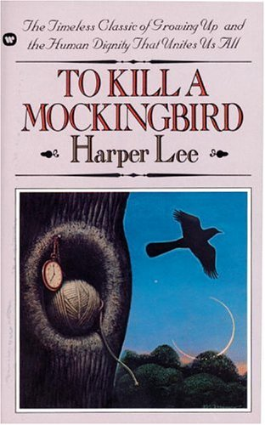
"Why reasonable people go stark raving mad when anything involving a Negro comes up, is something I don't pretend to understand."
-Atticus Finch in To Kill a Mockingbird
Jim Crow Laws Racism Lynching Segregation Civil Rights Movement South
Write an 8-sentence summary of this article. You must include (and underline) at least 5 of these vocabulary words in your summary.
______________________________________________________________________________________________________________________________________________________________________________________________________________________________________________________________________________________________________
______________________________________________________________________________________________________________________________________________________________________________________________________________________________________________________________________________________________________
__________________________________________________________________________________________________________________________________________________________________________________________________________________________________________________________________________________________________________________________________________________________________________________________________________________________________________________________________________________________________________
__________________________________________________________________________________________________________________________________________________________________________________________________________________________________________________________________________________________________________________________________________________________________________________________________________________________________________________________________________________________________________
____________________________________________________________________________________________________________________________________________________________________________________________________
______________________________________________________________________________________________________________________________________________________________________________________________________________________________________________________________________________________________________
____________________________________________________________________________________________________________________________________________________________________________________________________
Our novel, To Kill a Mockingbird, is about a white family who lives in the south during the 1930s, right when all of this racism took place.

