Name___________________________ Date________________________ Period__________________

Books Challenged or Banned 2012-2013- Discover what you’ve been missing
By Robert P. Doyle

Sex, profanity, and racism remain the primary categories of objections, and most occur in schools and school libraries. Frequently, challenges are motivated by the desire to protect children. While the intent is commendable, this method of protection contains hazards far greater than exposure to the “evil” against which it is leveled. U.S. Supreme Court Justice William Brennan, in Texas v. Johnson, said, “If there is a bedrock principle underlying the First Amendment, it is that the Government may not prohibit the expression of an idea simply because society finds the idea itself offensive or disagreeable.” Individuals may restrict what they themselves or their children read, but they must not call on governmental or public agencies to prevent others from reading or viewing that material.

The challenges documented in this list are not brought by people merely expressing a point of view; rather, they represent requests to remove materials from schools or libraries, thus restricting access to them by others. Even when the eventual outcome allows the book to stay on the library shelves and even when the person is a lone protester, the censorship attempt is real. Someone has tried to restrict another person’s ability to choose. Challenges are as important to document as actual bannings, in which a book is removed from the shelves of a library or bookstore or from the curriculum at a school. Attempts to censor can lead to voluntary restriction of expression by those who seek to avoid controversy; in these cases, material may not be published at all or may not be purchased by a bookstore, library, or school district.

Below is a chart that shows the primary reasons these books were challenged.
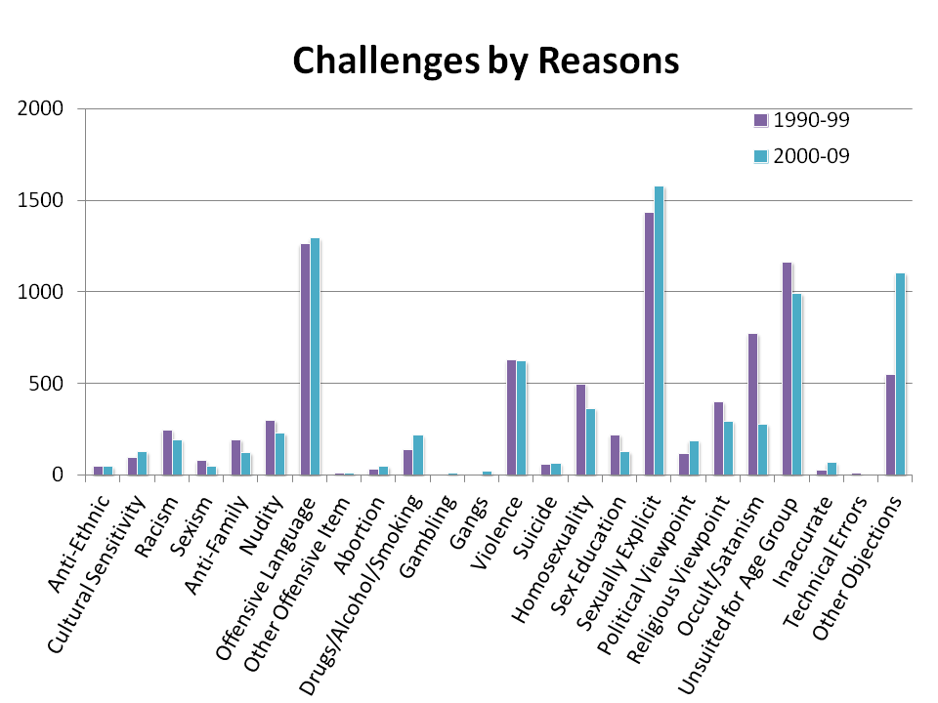
The bibliography below represents some of the many books challenged, restricted, removed, or banned in 2012 and 2013 as reported in the Newsletter on Intellectual Freedom from May 2012 to May 2013.

Ender’s Game- Card, Orson Scott
A teacher at Schofield Middle School in Aiken, S.C. (2012) will not face criminal charges for reading to his students from the science-fiction book. In addition to the Card novel — which has won several science-fiction awards and is listed on numerous children’s literature review websites as appropriate for readers twelve and older — the teacher read excerpts from an Agatha Christie novel and a young adult novel set in the Old West, officials said. The incident came to light after the materials were characterized by one student and one parent as pornographic.

The Perks of Being a Wallflower- Chbosky, Stephen
Challenged as an assigned reading at the Grandview Heights, Ohio High School (2012) because the book deals with drugs, alcohol, sex, homosexuality, and abuse.

The Kite Runner- Hosseini, Khaled
Challenged as optional reading in the tenth-grade honors class at Troy, Pa. area schools (2012) because the novel depicts a rape in graphic detail and uses vulgar language.

500 Years of Chicano History in Pictures
Banned from the Tucson, Ariz. Unified School District (2012)
In a district with over 60 percent of the students coming from Mexican-American backgrounds, the school board “dismantled its Mexican-American Studies program, packed away its offending books, shuttled its students into other classes,” according to a January 21, 2102, New York Times editorial because “it was blackmailed into doing so.” The Times referred to measures taken by Arizona Superintendent of Public Instruction John Huppenthal, who threatened to withhold millions of dollars if the school district didn’t terminate the nationally acclaimed program immediately. The superintendent has spent years crusading against ethnic studies programs that he claims are “brainwashing” children into thinking that Latinos have been victims of white oppression. On March 8, 2013, a federal court upheld most provisions of an Arizona state law used to prohibit the controversial Mexican-American Studies curriculum in Tucson. Activists plan to appeal the ruling to the U.S. Court of Appeals for the Ninth Circuit.

A Child Called It- Pelzer, Dave
Challenged at the Housel Middle School in Prosser, Wash. (2013) because the autobiography provides graphic depiction of child abuse. Middle-school students had to have parental permission to check out the book.

Romeo and Juliet- Shakespeare, William (No Fear Shakespeare)
Parents in Liberty, S.C. (2012) are furious about the book their kids are reading in middle school. They say it’s too mature for their kids because of the sex. The book in question is an easy-to-read version of Shakespeare’s Romeo and Juliet

The Hunger Games trilogy- Suzanne Collins
Reasons: anti-ethnic; anti-family; insensitivity; offensive language; occult/satanic; violence

Gossip Girl (series)- Cecily Von Ziegesar
Reasons: drugs; offensive language; sexually explicit content

To Kill a Mockingbird- Harper Lee
Reasons: offensive language; racism; sexually explicit content
Take Action! Protect Your Right to Read!

Each day, all across the country, one of our most basic freedoms — the right to read — is in danger. In communities large and small, censorship attempts threaten to undermine our freedom to read. Without our constant support, the First Amendment freedoms that we so often take for granted — the right to read, explore ideas, and express ourselves freely — are at risk.

The First Amendment guarantees that each of us has the right to express our views, including opinions about particular books. At the same time, the First Amendment also ensures that none of us has the right to control or limit another person’s ability to read or access information. Yet, when individuals or groups file formal written requests demanding that libraries and schools remove specific books from the shelves, they are doing just that—attempting to restrict the rights of other individuals to access those books.

The rights and protections of the First Amendment extend to children and teens as well as adults. While parents have the right—and the responsibility—to guide their own children’s reading, that right does not extend to other people’s children.

Similarly, each adult has the right to choose his or her own reading materials, along with the responsibility to acknowledge and respect the right of others to do the same.

When we speak up to protect the right to read, we not only defend our individual right to free expression, we demonstrate tolerance and respect for opposing points of view. And when we take action to preserve our precious freedoms, we become participants in the ongoing evolution of our democratic society.

