Name: _____________________ Period: _____
Annotation
C – 5
A – 2 ?’s
T – 3
C – 1 (3-5 sentence summary at the end)
H – 3 key facts

Early Aztec History

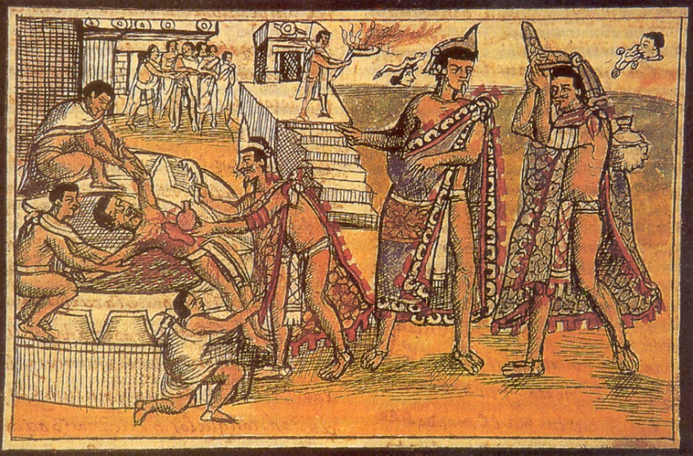

The exact origins of the Aztec people are uncertain, but they are believed to have begun as a northern tribe of hunter-gatherers whose name came from that of their homeland, Aztlan (or "White Land"). The Aztecs appeared in Mesoamerica--as the south-central region of pre-Columbian Mexico is known--in the early 13th century. Their arrival came just after, or perhaps helped bring about, the fall of the previously dominant Mesoamerican civilization, the Toltecs.

Typical Aztec crops included maize (corn), along with beans, squashes, potatoes, tomatoes and avocadoes; they also supported themselves through fishing and hunting local animals such as rabbits, armadillos, snakes, coyotes and wild turkey. Their relatively sophisticated system of agriculture (including intensive cultivation of land and irrigation methods) and a powerful military tradition would enable the Aztecs to build a successful state, and later an empire.

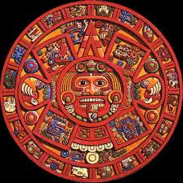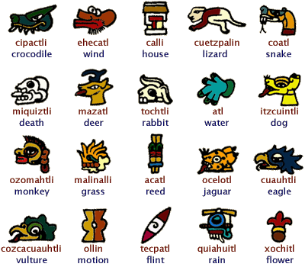

The Aztec Empire
In 1428, under their leader Itzcoatl, the Aztecs formed a three-way alliance with the Texcocans and the Tacubans to defeat their most powerful rivals for influence in the region, the Tepanec, and conquer their capital of Azcapotzalco. Itzcoatl's successor Montezuma (Moctezuma) I, who took power in 1440, was a great warrior who was remembered as the father of the Aztec empire.

Bustling markets such as Tenochtitlan's Tlatelolco, visited by some 50,000 people on major market days, drove the Aztec economy. The Aztec civilization was also highly developed socially, intellectually and artistically. It was a highly structured society with a strict caste system; at the top were nobles, while at the bottom were serfs, indentured servants and slaves. The Aztec faith shared many aspects with other Mesoamerican religions, like that of the Maya, notably including the rite of human sacrifice. In the great cities of the Aztec empire, magnificent temples, palaces, plazas and statues embodied the civilization's unfailing devotion to the many Aztec gods.

European Invasion & Fall of the Aztec Civilization
The first European to visit Mexican territory was Francisco Hernandez de Cordoba, who arrived in Yucatan from Cuba with three ships and about 100 men in early 1517. Cordobars reports on his return to Cuba prompted the Spanish governor there, Diego Velasquez, to send a larger force back to Mexico under the command of Hernan Cortes. In March 1519, Cortes landed at the town of Tabasco, where he learned from the natives of the great Aztec civilization, then ruled by Moctezuma (or Montezuma) II.

In November 1519, Cortes and his men arrived in Tenochtitlan, where Montezuma and his people greeted them as honored guests according to Aztec custom (partially due to Cortes' physical resemblance to the light-skinned Quetzalcoatl, whose return was prophesied in Aztec legend). Though the Aztecs had superior numbers, their weapons were inferior, and Cortes was able to immediately take Montezuma and his entourage of lords hostage, gaining control of Tenochtitla. The Spaniards then murdered thousands of Aztec nobles during a ritual dance ceremony, and Montezuma died under uncertain circumstances while in custody. After his victory, Cortes razed Tenochtitla and built Mexico City on its ruins.

